WelcomeBike Neural Network Summary
Predicting Hourly Rental Rates
Elijah Kearl | Austin Bitsoi | Davin van den Akker | Kimie Jensen

Model Value
Our model provides value by accurately identifying peak rental times by hour. These estimations are vital for our ability to maintain our bike fleet without impacting fleet capacity at high-rental times.
However, a beautiful way to capitalize on our predictive powers is by having adaptive prices for our bike rentals.
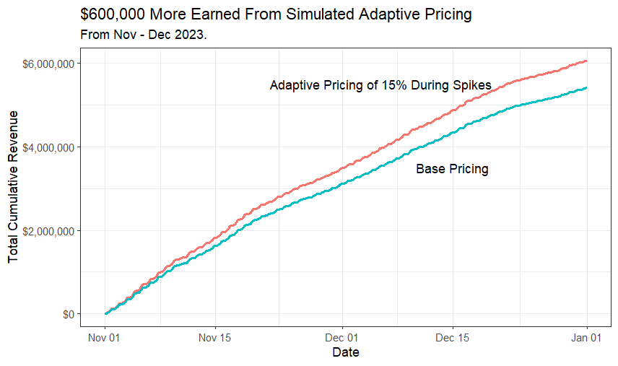
Using some assumptions, such as a bike rental lasting for 1 hour, and costing $10 (a price that our competitors currently use https://capitalbikeshare.com/pricing), we can come up with an estimated total cumulative earnings using our models' predicted rental rates per hour. If we then change our pricing to be adaptive, so that when the rental rates are 125% or over the mean rental rates per day, the rental price increases by 15%, we can come up with our total cumulative earnings while utilizing adaptive pricing.
Over November and December, we would have been in the ballpark of ~$600,000 more than we would have otherwise made.
Our team will stress that this number is heavily reliant on our assumptions, but the point is clear. Our model is capable of making you hundreds of thousands more dollars within months, as long as you utilize it for adaptive pricing.

Data Insights

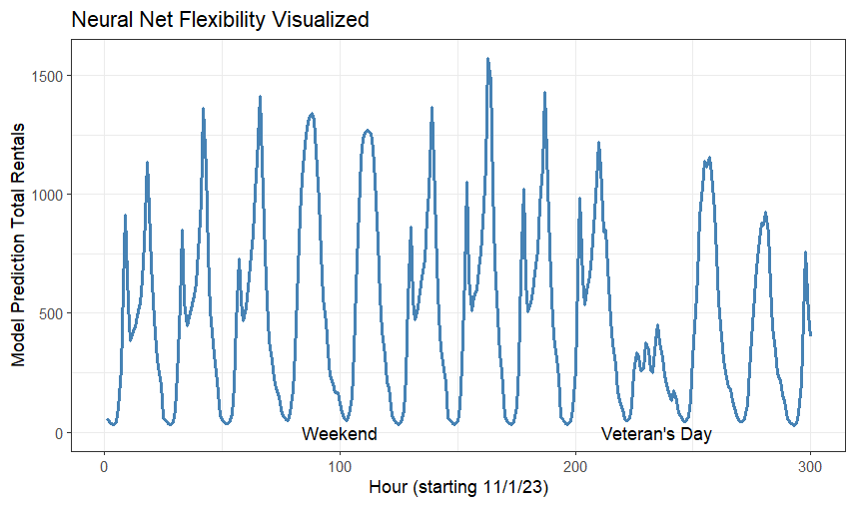
One of the things that shows the capability of our neural network is the distinctions it makes on the “type of day” it’s predicting. As you can see, our model largely predicts weekdays in a sort of “two peaks” line. A peak happens around 8am, then the rentals shallow out before another peak at 5pm happens. The rentals then decline until the next weekday, where the cycle repeats. This is likely related to commutes to and from work.
On weekends, our model predicts a different shape. We see our model makes a peak at 3pm, however the “tip” of that peak is sustained from 11am to 5pm. This is likely due to the fact that people are renting our bikes to commute to weekend activities, or even using the rental as their weekend activity.
Lastly, we see how our model handles holidays. On holidays, we see a cut in rentals happening, although that lower baseline typically sustains itself across the day. This can be explained by the fact that people are often interacting with family and friends in homes on the holidays.
What this means is that when performing routine maintenance on bikes, such as cleaning or repairs, it’s essential we avoid our peak rental times. Ideally, doing these bike rotations would be done between 11pm-6am, as that is a constant low-rental time regardless of the factors previously mentioned. If that is unable to happen, it would be worthwhile to maintain bikes on holidays or between 10am-1pm on weekdays. Ultimately, it seems like a combination of night and daytime maintenance might be required for our large fleet size.

Company Almost Fully Recovered After Decline during COVID
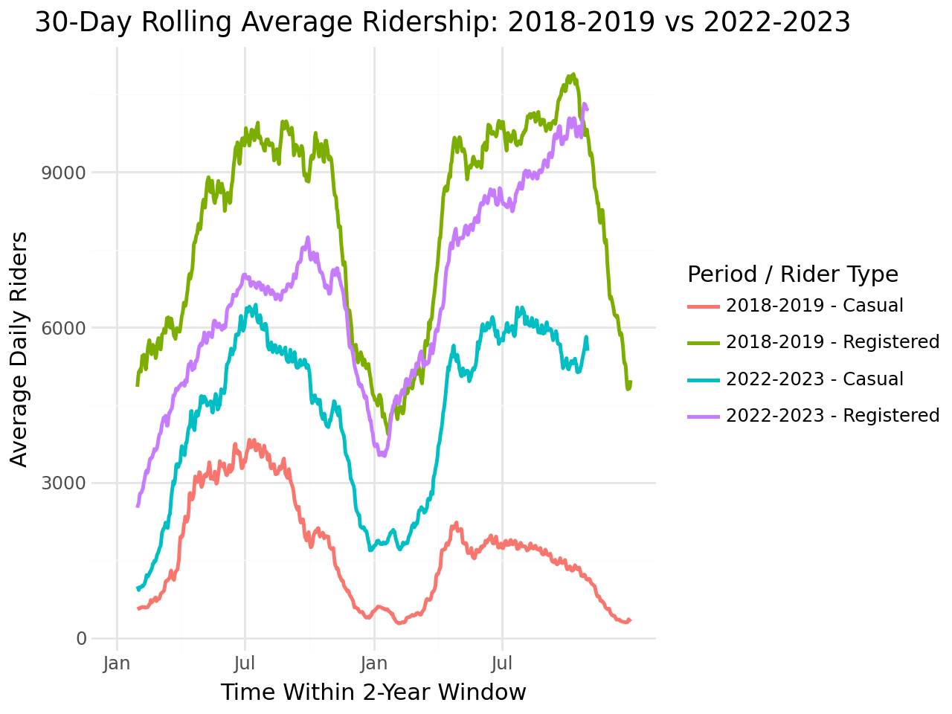
Though the amount of rental significantly declined during the COVID area, it appears that by the end of 2023 we have made an almost complete recovery from the decline. Taking into account both rental benchmarks: Casual and Registered, post-covid we have a significant increase in our casual riders however the registered riders were still lacking during the summer of 2022.
However, the summer of 2023 has shown great promise as we can see a continuous increase in the amount of registered riders riding, with the final months of summer showing near pre-COVID numbers. If the trend continues through the future summers, the company will have overcome its current dynamic of lots more casual riders and fewer registered from the year before.
Technical Details
Throughout the development of our predictive architecture, we evaluated several structural methodologies to optimize performance. Initial iterations explored a dual-output system within a single model to differentiate between casual and registered users, while others attempted to train on a singular aggregated sum. Ultimately, our most effective approach involved deploying two distinct models trained independently before consolidating their results. This dual-model strategy consistently surpassed the predictive accuracy of models trained on the aggregated sum.
To achieve peak performance, we implemented an algorithmic tuning protocol that systematically refined our model's architecture—adjusting layer depth, node density, activation functions, and dropout rates. Our findings revealed that increasing depth significantly enhanced the model's ability to extract complex patterns. While early designs utilized only 2-5 layers, our most sophisticated submission successfully integrated 17 layers to maximize data insights.
The learning rate dictates the precision of the model's descent toward an optimal solution. Excessive rates risk overshooting the absolute minimum, while insufficient rates can trap the model in suboptimal local minima. To navigate this trade-off, we utilized an adaptive learning rate. This technique allows for aggressive initial progress followed by systematic reductions as training plateaus, ensuring the model captures every possible efficiency at the point of convergence.
Refinement of our hyperparameters resulted in a median absolute error of 45.98, indicating that our daily rental forecasts typically vary by fewer than 50 units. While additional data would further sharpen this accuracy, the current model provides a highly reliable metric for estimating demand. We suggest slightly over-allocating fleet resources relative to these estimates, as the revenue potential of an available bike outweighs the minor cost of deployment in instances of under-prediction.

Model Code
https://github.com/aehng/base_ml_project

